|  |
| --- |
| **Team ID :** LTVIP2025TMID32402 |
| Project Name : Enchanted Wings: Marvels of Butterfly Species |

**Data Visualization**

**The provided Python code imports necessary libraries and modules for image manipulation. It selects a random image file from a specified folder path. Then, it displays the randomly selected image using IPython's Image module. This code is useful for showcasing random images from a directory for purposes like data exploration or testing image processing algorithms.**

**Explanation:**

**This code snippet performs several tasks related to handling image files within a specified directory (folder_path):**

1. **Lists image files with extensions like .jpg, .png, .jpeg.**
2. **Randomly selects one image file from the list.**
3. **Constructs the full file path to the selected image.**
4. **Displays the image using a display function suitable for the environment (like Jupyter Notebook).**

**Sample Code:**

**python**

**CopyEdit**

**import os**

**import random**

**from IPython.display import Image, display**

**# Specify the folder path containing images**

**folder_path = "path_to_your_image_folder"**

**# Get a list of image files in the folder**

**image_files = [file for file in os.listdir(folder_path) if file.endswith(('.jpg', '.png', '.jpeg'))]**

**# Select a random image**

**selected_image = random.choice(image_files)**

**# Construct the full path to the image**

**image_path = os.path.join(folder_path, selected_image)**

**# Display the selected image**

**display(Image(filename=image_path))**

**This simple visualization approach helps verify dataset quality, spot anomalies or patterns, and better understand the data before building models.**

**Data Visualization**

The provided Python code imports necessary libraries and modules for image manipulation. It selects a random image file from a specified folder path. Then, it displays the randomly selected image using IPython's Image module. This code is useful for showcasing random images from a directory for various purposes like data exploration or testing image processing algorithms.

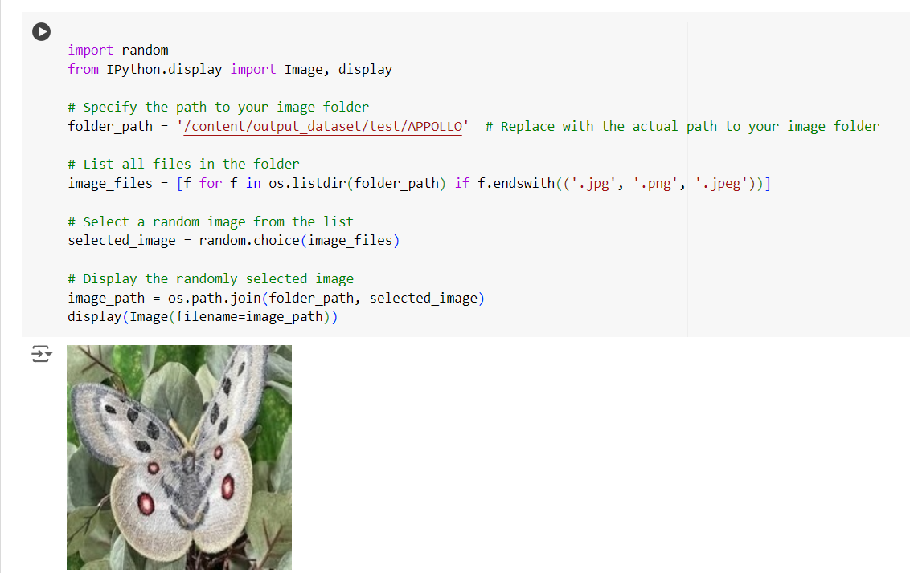

This code snippet performs several tasks related to handling image files within a specified directory (folder_path). Initially, it lists all files in the directory (folder_path) that have file extensions commonly associated with image files (.jpg, .png, .jpeg). It then randomly selects one image file (selected_image) from the list of files retrieved. Finally, it constructs the full path to the randomly selected image file (image_path) and displays it using the display function, assuming an environment where this function can render the image directly in the output..

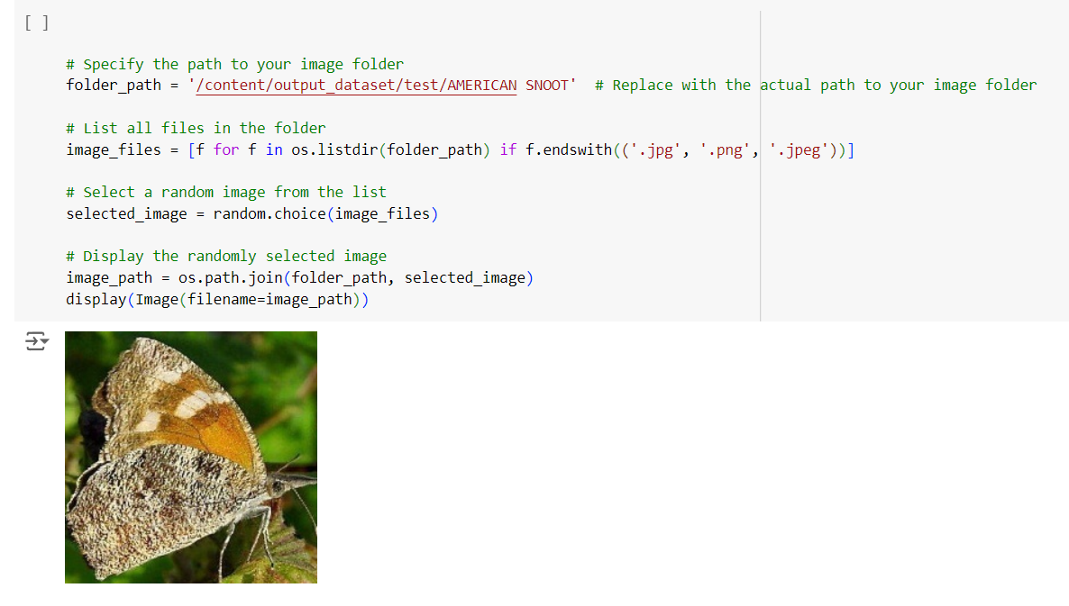

This code snippet performs several tasks related to handling image files within a specified directory (folder_path). Initially, it lists all files in the directory (folder_path) that have file extensions commonly associated with image files (.jpg, .png, .jpeg). It then randomly selects one image file (selected_image) from the list of files retrieved. Finally, it constructs the full path to the randomly selected image file (image_path) and displays it using the display function, assuming an environment where this function can render the image directly in the output.